**27 March, 2023**

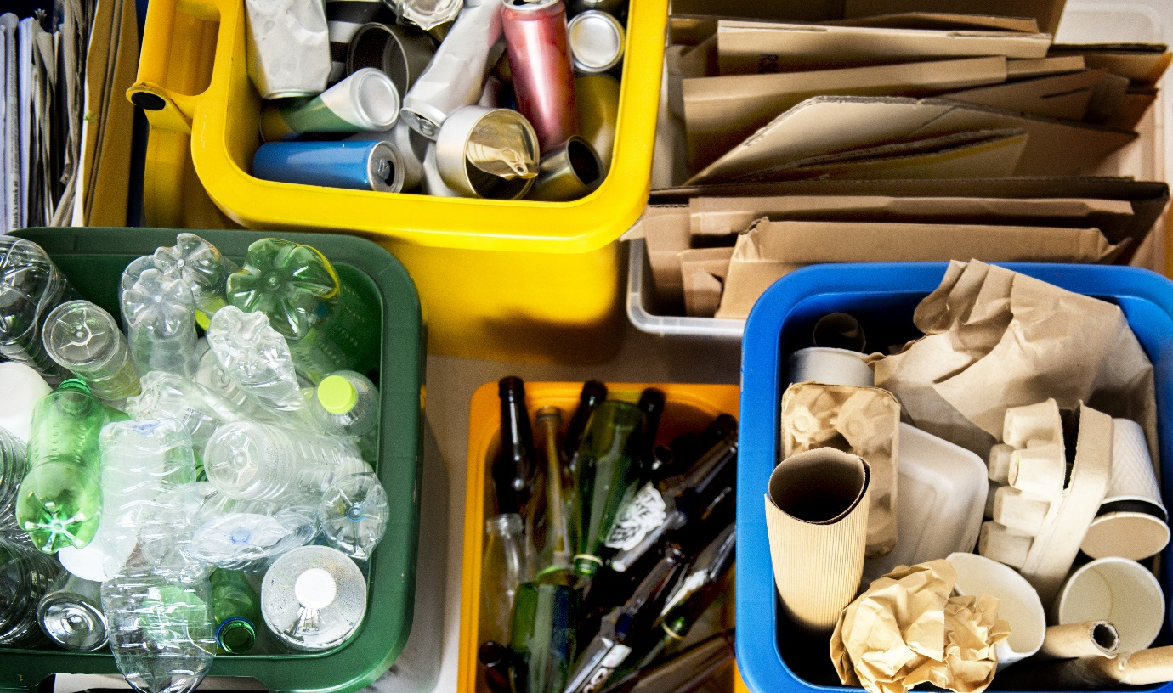

**Image: Shutterstock**

**THE GOOD FIGHT: THE CHANGING FACE OF ISUZU’S PACKAGING PUSH**

Isuzu Australia Limited (IAL) is advanced in its plans to meet the recycling and repurposing targets that form the company’s pledge to the Australian Packaging Covenant Organisation (APCO).

APCO is a is a not-for-profit organisation leading the development of a circular economy for more sustainable packaging strategy in Australia.

The aim of the covenant is to keep packaging materials out of landfill by retaining the maximum value of the materials, energy and labour within the local economy. Put simply: reduce, reuse, recycle.

Like many companies charged with the distribution of products with large amounts of freight packaging, Isuzu has taken the pledge to meet APCO’s 2025 targets and are making solid strides towards this goal.

**ADVANCING AIMS**

The nation’s top truck brand is tackling the problem from several different angles and already has a strong overall APCO performance rating putting them well on track to meet their 2025 obligations.

APCO’s 2025 target include…

* 100 per cent reusable, recyclable or compostable packaging;
* 70 per cent of plastic packaging being recycled or composted;
* 50 per cent of average recycled content included in packaging; and
* the phase-out of unnecessary single-use plastics packaging.

IAL Head of Supply Chain, John Plunkett, has been vocal about his support and enthusiasm for the project.

“Our parts distribution division of the business is a huge operation, servicing a massive footprint throughout Australia and the broader South Pacific region.

“Our volumes have grown significantly in recent years, so continuing to take decisive action and increasing the reuse and recycling of our inbound and outbound packing was something the organisation did without hesitation,” Mr Plunkett said.

I know this is something that’s very dear to a lot of people at Isuzu, myself included and it is an ever-evolving process~~.”~~

**CHANGE STARTS AT HOME**

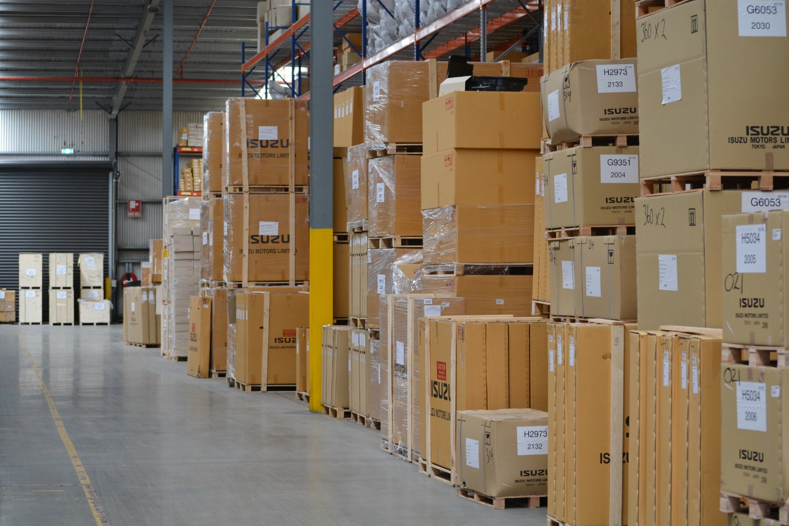

IAL’s vast parts processing facility in Melbourne’s west illustrates the scale of the company’s packaging footprint.

The 15,000-square-metre facility holds approximately 35,000 lines of stock across 33,000 locations.

The team pick an average of 2,500 lines of inventory every day, which equates to more than 2.5 million pieces every year. From that, more than 70,000 freight consignments are shipped every year.

The Isuzu Parts operation picks, packs and ships around 7300 tonnes of parts every year, with the volume growing annually as the company continues breaking sales records.

This represents an immense amount of inbound packaging from its parent company in Japan and outbound across the Oceania region including Australia, New Zealand and the Pacific Islands.

**GRADUAL CHANGE**

“It been critical that the adoption of APCO compliance be established from the ground up,” said Mr Plunkett.

“Any other approach simply wouldn’t have been effective for an operation of this scale.”

Isuzu’s Parts department have managed to re-use or recycle approximately 90 per cent of all packaging that comes in from overseas, which is a sizable quantity of material being kept out of landfill and in circulation.

Anything that can be recycled is separated and reused to send componentry to Isuzu dealerships and other items are disposed of as per APCO protocols.

The packaging that leaves the warehouse is, in many cases, made from recycled material that can all be reused and recycled.

Outbound bubble wrap is now made up of 30 per cent recycled material while itself remaining fully recyclable. With biodegradable packaging tape and recyclable shrink wrap to be introduced this year, Isuzu’s newly formed Supply Chain department is challenging itself to go as green as possible.

Additional initiatives include packaging type reductions and an expanded use of recyclable packaging that features and advertises the universal 100 per cent recycling mobius logo.

**SHOULDERS TO THE WHEEL**

“It’s been really pleasing to see some of the imagination and ingenuity that has gone into some of these measures,” said Mr Plunkett

“It might be a consequence of the work that I do, but when I see our staff apply that kind of outside-the-box thinking - to come up with solutions that benefit all of us.

“I’m very proud of our team.”, he said.

“All of this is monitored by an in-house APCO committee with all Isuzu departments represented. This way, the entirety of Isuzu is moving towards a greener future together.”

APCO’s 2025 deadline is a milestone, not a finish line and Isuzu has no intention of allowing standards to slip.

Isuzu’s vast dealer network have enthusiastically embraced the program too, with many investigating additional ways to reduce and reuse throughout their own localised supply chains.

“It’s an exciting time, there’s still so much open road for us to explore.” said Mr Plunkett

**Ends**

**For further information, please contact:**       **For Isuzu Trucks releases and photos:**

Sam Gangemi                                                                  Arkajon Communications

Isuzu Australia Limited                                               Phone: 03 9867 5611

Phone: 03 9644 6666                                                 Email: [isuzu@arkajon.com.au](mailto:isuzu@arkajon.com.au)

**Images here:** [**https://isuzu.imagerelay.com/sb/2c771787-419c-4a56-b493-6c8eb2511c88/wmr-placement-apco-piece**](https://isuzu.imagerelay.com/sb/2c771787-419c-4a56-b493-6c8eb2511c88/wmr-placement-apco-piece)